American Horror Story Inspired Project

<https://www.youtube.com/watch?v=VPTwNuc5b3c>

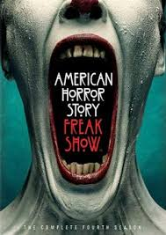

American Horror Story: Freak Show Disorder Project

**Introduction**:

Genetic disorders are one of the most fascinating parts of biology class. There seems to be a morbid interest in the things that can go wrong with the human genome.

**History of the “Freak Show”:**

In the mid-16th century, freak shows became popular pastimes in England. Deformities began to be treated as objects of interest and entertainment, and the crowds flocked to see them exhibited. As well as exhibitions, freak shows were popular in the [taverns](https://en.wikipedia.org/wiki/Tavern) and fairgrounds where the freaks were often combined with talent displays.

Today, though, there is a stigma against gawking at people who are different, and the word “freak” is considered highly offensive. Freak shows have dwindled as the years have passed. According to one source they believed they were banned as late as 1980.

Video link #1: <https://www.youtube.com/watch?v=26uiMJAC0ec>

Video link #2: <https://www.youtube.com/watch?v=9nCEn-ShfZ0>

**Project Assignment**:

Many of the individuals that were in Freak Shows had genetic disorders, developmental abnormalities, diseases or disorders. For each of the individuals in this packet (some based on the series *American Horror Story: Freak Show* and others were real people in freak shows of the past).

**Find out the following:**

1. What is the name of condition or disorder that the person/character has?

2. Describe in detail the disease/disorder/condition.

3. What is the cause(s) of the disease/disorder?

4. Who can be affected by this disease/disorder?

5. Name of real person(s) that are/were affected by the disorder?

**Individual #1: Elephant Man**

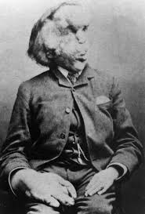

**Individual #2: Lobster Boy**

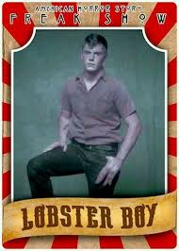

**Individual #3: “Pepper”**

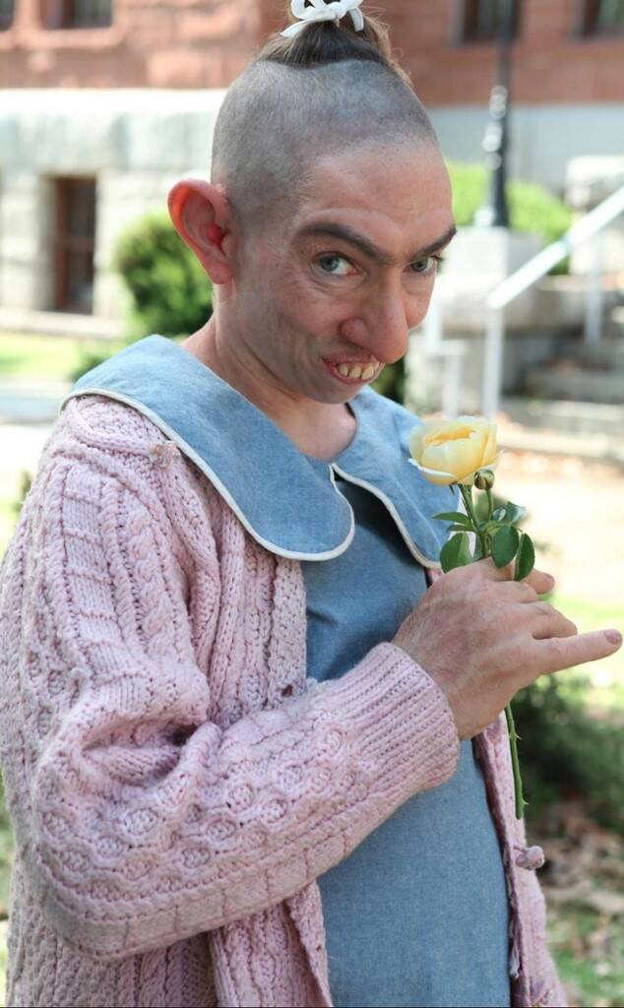

**Individual #4: “Ma Petite”**



**Individual #5: The Skeleton Man**

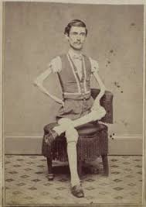

**Individual #6: The Dog Faced Man**

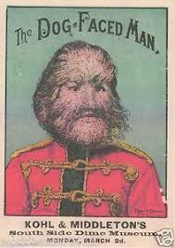

**Individual #7: Two Headed Girl**

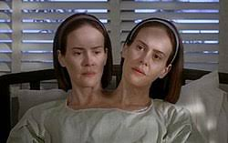

**Individual #8: Bearded Lady**

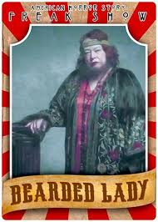

**Individual #9: The Ohio Big Foot Girl**

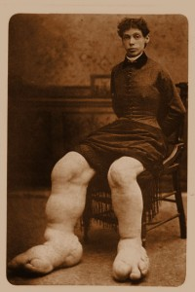

**Individual #10: Elastic Man**

